Network Analysis and Visualization in Twitter
- Overview
The vast amount of social connections reside in social media platforms, for example, the friendship network, the following/follower network, and the text mentioning, replies and forwarding network. Network analysis and visualization describe the tasks of understanding this structure and has emerged as a key technique in modern sociology.
The SMILE application is able to extract three types of networks from each Tweet: the "mentions" network, "reply to" network, and the "retweet" network. The NetworkX library is running in the back end to construct the network, provide the layout, as well as calculate important metrics for the network. All the generated results and compatible format of the network graphs are open for download. Users can perform additional analysis as well as reproduce visualization in some of the popular network analysis tools, such as Gephi, D3, and Pajek.
Tweets

Downloadable Results

Network Visualization

NetworkX
This is generated when the user specifies a term to search in the "social media search" page and is saved on user's home directory.
The Python NetworkX library has been used here.
Downloadable and visualization is available in the “NetworkX” web page.

Figure 1. Overall workflow of the network visualization

- Extract the connections from tweet
The data fetched from twitter's RESTful API and our elasticsearch archive has been transformed to a tabular format (.csv) with each column represents a field, and each row represents an individual tweet/record. These data have been stored in the session folder under each user's home directory and the SMILE application creates an interface to interact with those data. In the "NetworkX" web page and under the configuration panel, there's a drop-down box named "select from your folder" which lists all the available data on disk; once a file has been selected, a preview of the tweet will appear (Figure 2). The required connections to create a network will be generated from the aforementioned tweet collection that you select.
There are three different network relation that can be extracted from each tweet:
Retweet from: Retweet network is a directional network. Nodes in this network represent the Twitter users, while the edges represent the retweets. It is generated by extract the "RT @XXX" within the tweet. The edge will an arrow starting from the retweeter and pointing towards the author of the original tweet. Ex. “A: RT @B tweet content…” will result in a network of “A B”
- Reply to: A reply relationship is a special form of “mention” that occurs when the user’s name is at the very beginning of a tweet (ex: “@itaih just spoke about social media”). The edge will an arrow starting from the author of this tweet and pointing towards the author being replied to. Ex. “A: @B tweet content…” will result in a network of “A B”
- Mentions: A mentions edge is created when one user creates a tweet that contains the name of another user (indicated with a proceeding “@” character, ex: “just spoke about social media with @marc_smith”). The edges will be arrows starting from the author of this tweet and pointing towards the authors being mentioned in the tweet. Ex. “A: @B @C tweet content @D…” will result in a network of “A B; A C; A D”
A python script is performing such extraction utilizing a computer science technique called regular expression. A pattern can be easily searched for and matched given a regular expression which is a special text string for describing the pattern. In our application, we use such method to acquire the user ID, since user ID is always in conformity with a set of rules:
- Consist of alphanumeric values and underscore;
- Always associate with special characters such as “@” and “RT”;
- Always appear in the beginning for a “Reply to” relation.

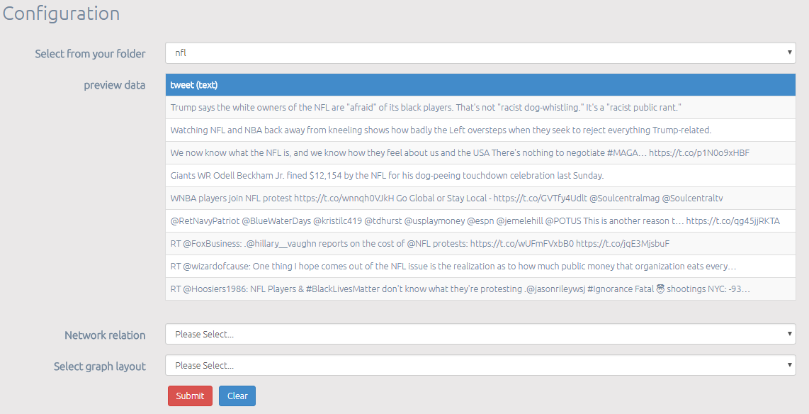
5 layouts are available: Random, Circular, Fruchterman, Shell and Spectral layout
Three relations are available: Retweet from, Reply to, and Mentions
Select the data available to perform sentiment Analysis on
Figure 2. Configuration panel for the Network analysis and visualization

- Network creation and visualization
After deciding the desired relation to study, a directed network will be created. The node will be the twitter user, and the edge will be their connection. The tweet text will be appended to their edges.
A large network with too many nodes and edges will put a severe strain on user’s Graphics and browser. Hence, when dealing with large network visualization, we “prune” it to only 500 nodes (twitter users) based on the degree centrality of each node. The degree centrality for a node v is the fraction of nodes it is connected to, and the values are further normalized by dividing by the maximum possible degree in a simple graph n-1 where n is the number of nodes in G. Note: the pruning is only for visualization purpose. All the metrics and the exported graph file are still based on the original network extracted from tweets.
The layout will decide that position of the nodes on the visualization. See Figure 3 for an example of Fruchterman layout. We currently have 5 layout options for you that are supported by NetworkX library.
- Random layout: Position nodes uniformly at random in the unit square.
- Circular layout: Position nodes on a circle.
- Fruchterman layout: Position nodes using Fruchterman-Reingold force-directed algorithm.
- Shell layout: Position nodes in concentric circles.
- Spectral layout: Position nodes using the eigenvectors of the graph Laplacian.
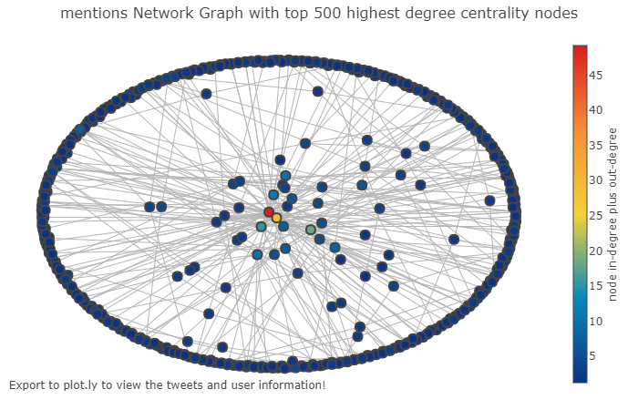
Figure 4. Mentions network with a Fruchterman layout

Each node (twitter user) is colored based on their connectivity. We calculate their connectivity by adding up their in-degree, which is the number of incoming edges, and out-degree which is the number of outgoing edges. High connectivity indicates highly influential twitter user.

- Measure the network
We provide several measurements of the network to help the user to understand network both structurally and quantitatively:
- The assortativity of the network: assortativity or assortative mixing is a preference for a network's nodes to attach to others that are similar in some way. Network theorists often examine assortativity in terms of a node's degree. We provide a ".CSV" file of the measurement, with the columns as the degree, average degree connectivity, and k nearest neighbors⁹.
- The overview of the node attributes including: degree centrality, in degree centrality, out degree centrality, closeness centrality, betweenness centrality, load centrality, average neighbor degree, square clustering, and closeness vitality. The result will be saved in a .CSV file named “node_attributes.csv”
- The overview of the edge attributes including: edge betweenness centrality and edge load.
- Strongly connected component¹⁹ is a subgraph of a directed graph G, and within this subgraph, there is a path in each direction between each pair of vertices of the graph.
- Weakly connected component is a maximal subgraph of a directed graph such that for every pair of vertices (u, v) in the subgraph, there is an undirected path from u to v and a directed path from v to u.
- The triadic census of the network is a count of how many of the 16 possible types of triads are present in a directed network graph. Triads consist of 3 nodes, is one of the simplest human groups that can be studied (Figure 5).
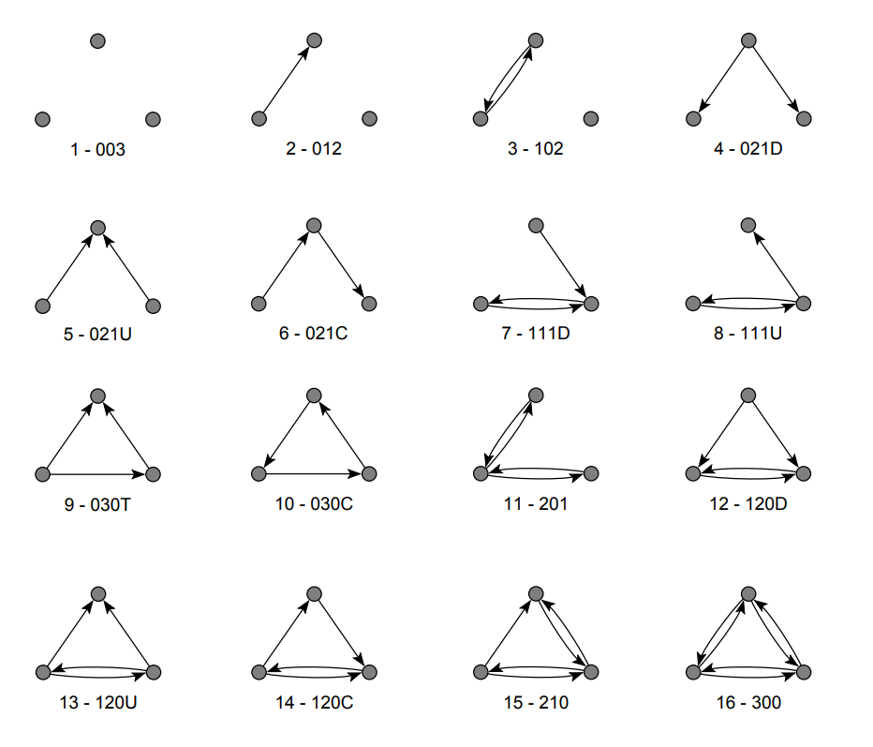
Figure 5. 16 possible types of triads

https://networkx.github.io
https://gephi.org
https://d3js.org
http://vlado.fmf.uni-lj.si/pub/networks/pajek/howto.htm
https://docs.python.org/2/library/re.html
https://docs.python.org/2/library/re.html
https://networkx.github.io/documentation/networkx-1.9/reference/generated/networkx.algorithms.centrality.degree_centrality.html
https://networkx.github.io/documentation/networkx-1.9.1/reference/algorithms.assortativity.html
A. Barrat, M. Barthélemy, R. Pastor-Satorras, and A. Vespignani, “The architecture of complex weighted networks”. PNAS 101 (11): 3747–3752 (2004).
https://networkx.github.io/documentation/networkx-1.10/reference/generated/networkx.algorithms.centrality.in_degree_centrality.html
https://networkx.github.io/documentation/networkx-1.10/reference/generated/networkx.algorithms.centrality.out_degree_centrality.html#networkx.algorithms.centrality.out_degree_centrality
https://networkx.github.io/documentation/networkx-1.10/reference/generated/networkx.algorithms.centrality.closeness_centrality.html#networkx.algorithms.centrality.closeness_centrality
https://networkx.github.io/documentation/networkx-1.10/reference/generated/networkx.algorithms.centrality.betweenness_centrality.html#networkx.algorithms.centrality.betweenness_centrality
https://networkx.github.io/documentation/networkx-1.10/reference/generated/networkx.algorithms.centrality.load_centrality.html#networkx.algorithms.centrality.load_centrality
https://networkx.github.io/documentation/networkx-1.10/reference/generated/networkx.algorithms.assortativity.average_neighbor_degree.html#networkx.algorithms.assortativity.average_neighbor_degree
https://networkx.github.io/documentation/networkx-1.10/reference/generated/networkx.algorithms.cluster.square_clustering.html?highlight=square%20clustering#networkx.algorithms.cluster.square_clustering
https://networkx.github.io/documentation/networkx-1.10/reference/generated/networkx.algorithms.vitality.closeness_vitality.html?highlight=closeness%20vitality#networkx.algorithms.vitality.closeness_vitality
https://networkx.github.io/documentation/networkx-1.10/reference/generated/networkx.algorithms.centrality.edge_betweenness_centrality.html?highlight=edge%20centrality#networkx.algorithms.centrality.edge_betweenness_centrality
Skiena, S. Implementing Discrete Mathematics: Combinatorics and Graph Theory with Mathematica. Reading, MA: Addison-Wesley, 1990.
Vladimir Batagelj and Andrej Mrvar, A subquadratic triad census algorithm for large sparse networks with small maximum degree, University of Ljubljana, http://vlado.fmf.uni-lj.si/pub/networks/doc/triads/triads.pdf

